Proof of the Pythagorean Theorem:

Proof with four right triangles and a square-

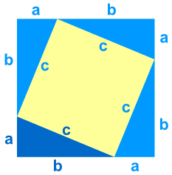Given the figure showed on the left, we can prove the Pythagorean Theorem. Consider the area of the larger square. Since the area of a square is the side length squared we can write: ${\left(a+b\right)}^{2}=area of the square.$ Now because the yellow square and the four blue right triangles also equal the area of the square we write: $c^{2}+4\left(\frac{1}{2}\left(b\right)\left(a\right)\right)={\left(a+b\right)}^{2}$. Now using basic Algebra skills we can prove:

$${\left(a+b\right)}^{2}=c^{2}+4\left(\frac{1}{2}\left(b\right)\left(a\right)\right)$$

$$a^{2}+2ab+b^{2}=c^{2}+2ab$$

$a^{2}+b^{2}=c^{2}$, which is the Pythagorean Theorem.